**Experiment No. 3**

**LINUX**

1. **Desktop:**

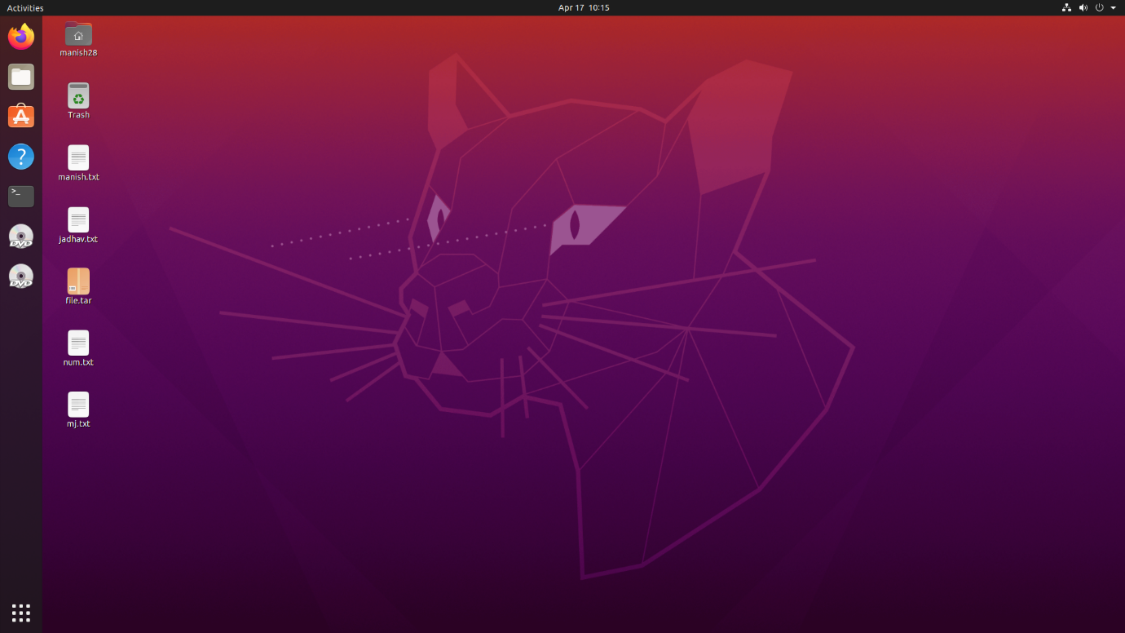

1. **File Manager:**

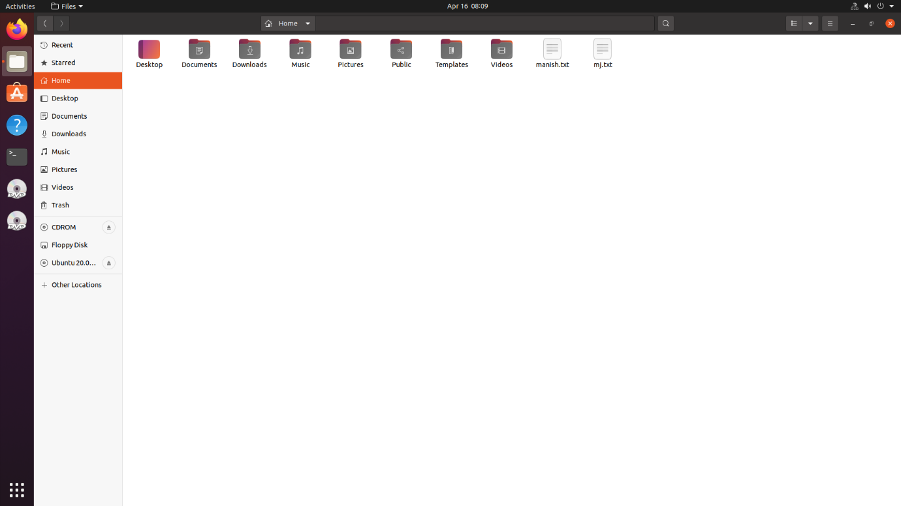

1. **Application Manager:**

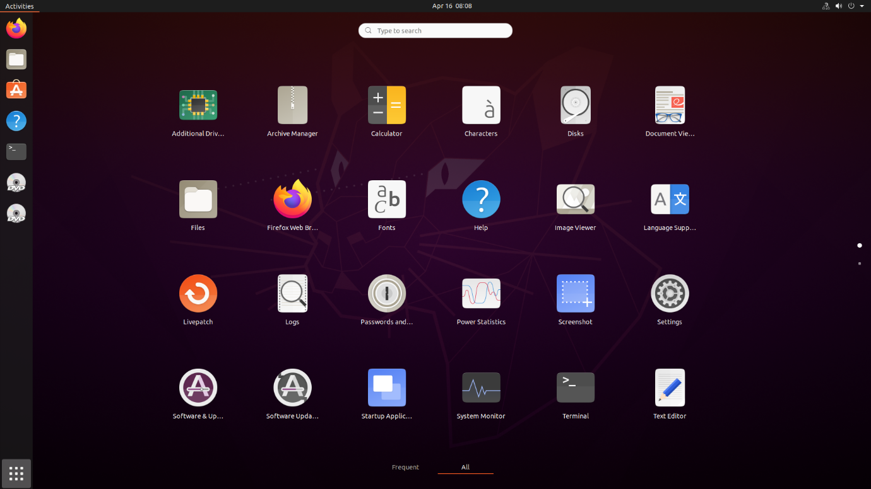

1. **Application interface (Ex. Calculator):**

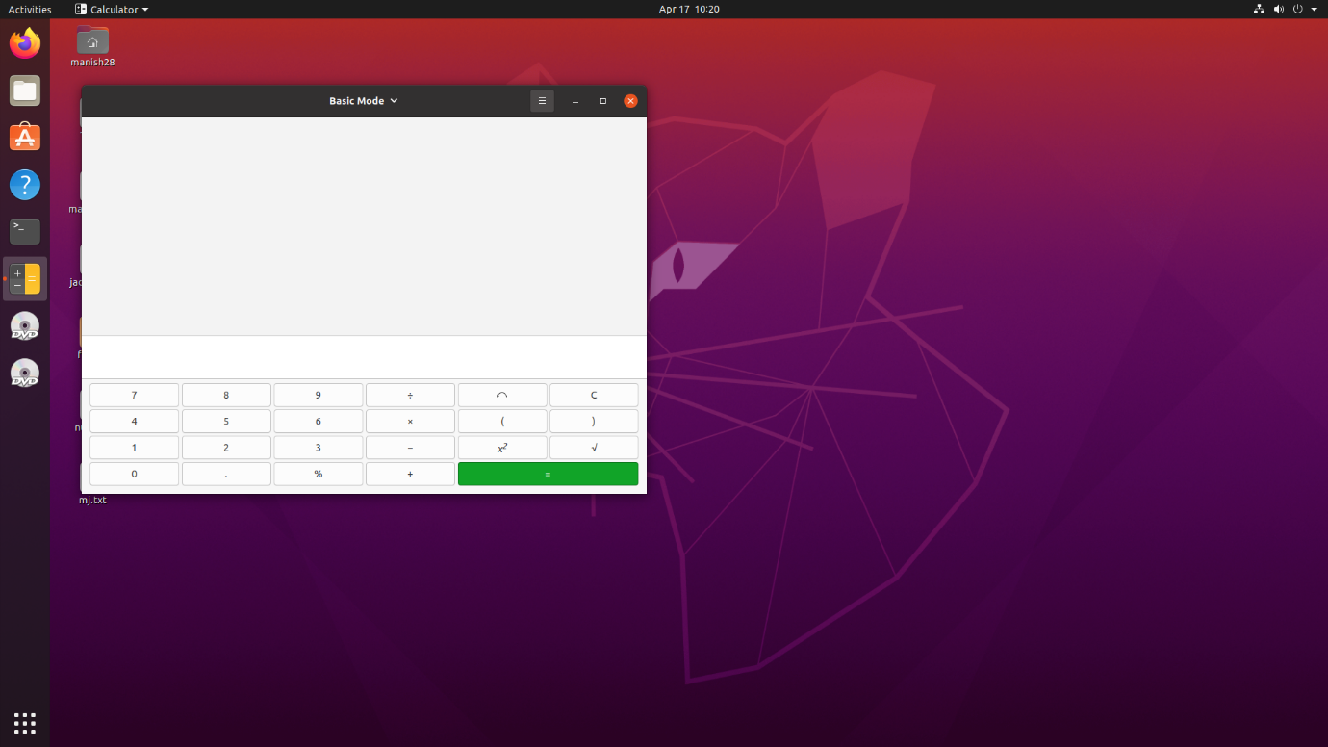

1. **Browser of Linux:**

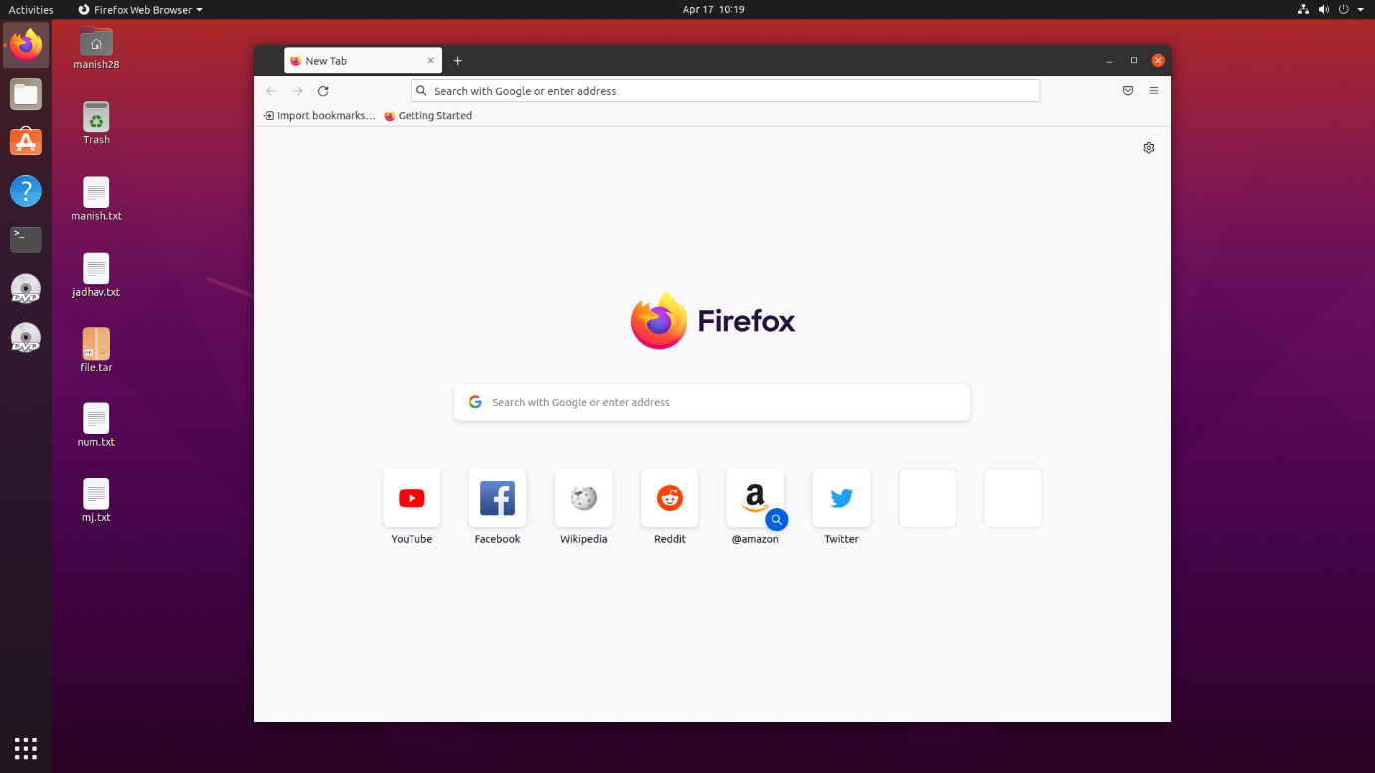

1. **Settings:**

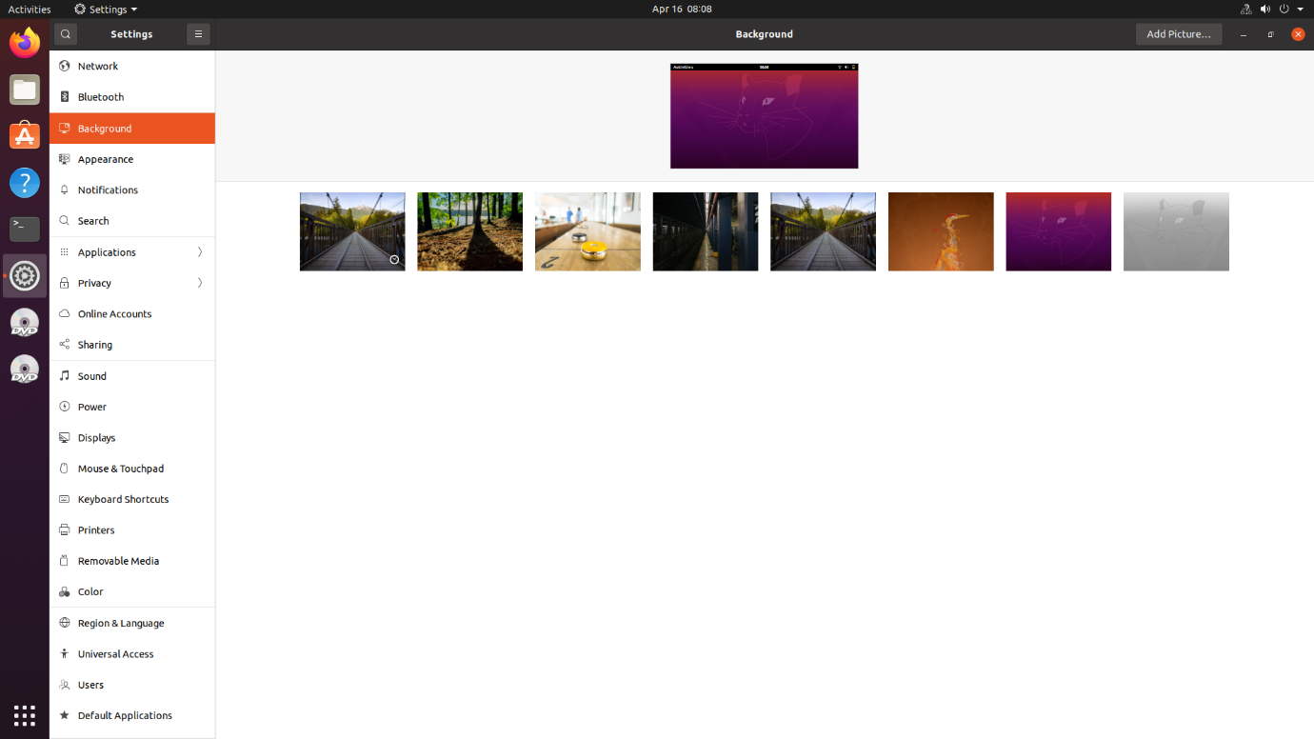

**K Desktop Environment (KDE)**

1. **Application Manager:**

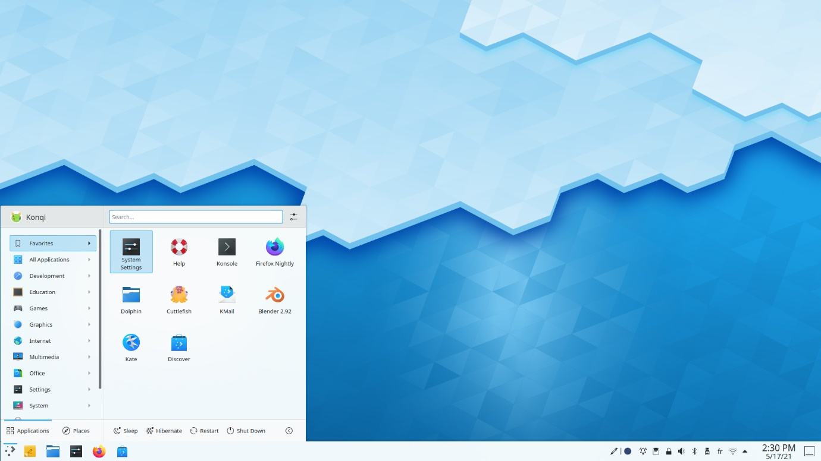

1. **File Manager of KDE:**

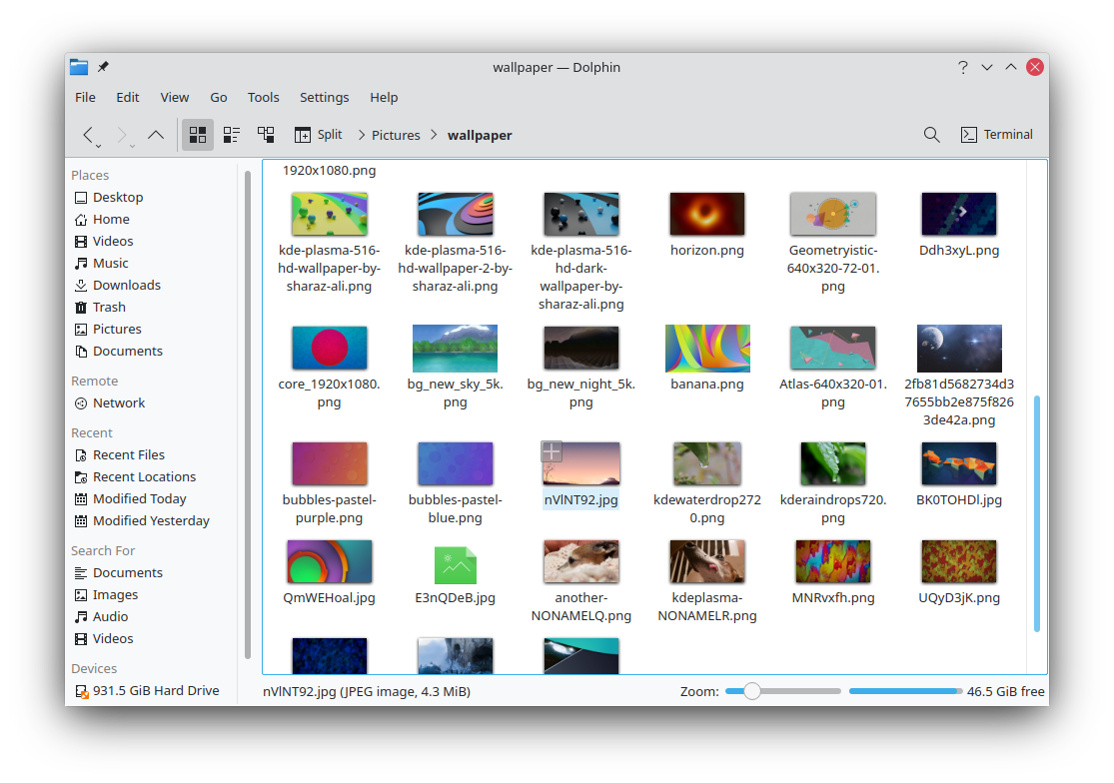

1. **Appstore of KDE:**

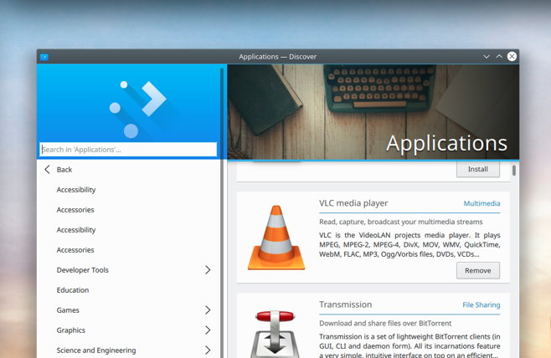

1. **Settings UI of KDE:**

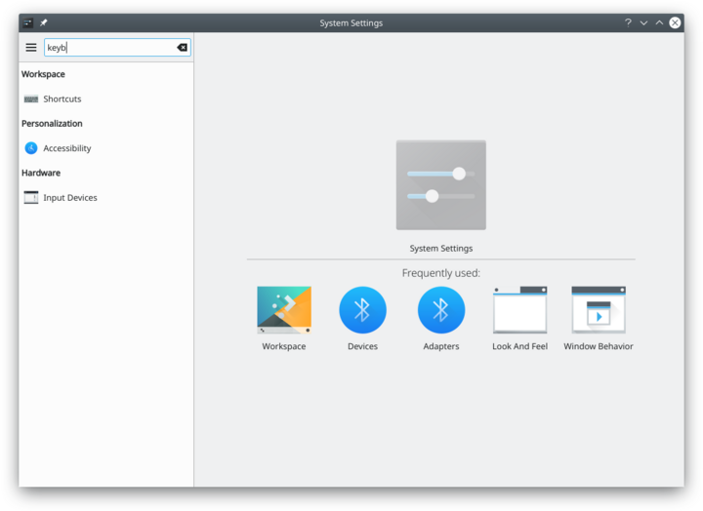

1. **Application interface of KDE (Ex. Calculator):**

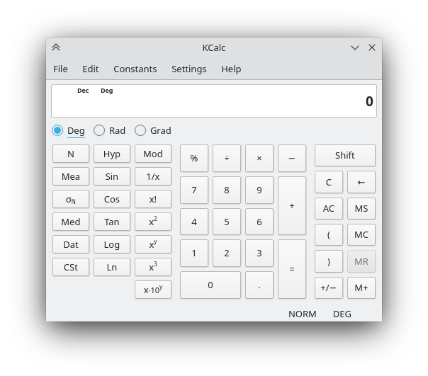

|  |  |  |  |
| --- | --- | --- | --- |
| **Practical Performance**  **(4)** | **Writeup & Oral**  **(4)** | **Attendance**  **(2)** | **Total**  **(10)** |
|  |  |  |  |